APWH

**COLD WAR TIMELINE PROJECT**

Essential Questions:

**1. What were the causes and effects of the ideological struggle of the Cold War.**

**2. In what ways did both the Soviet Union and the United States seek to maintain influence during the Cold War?**

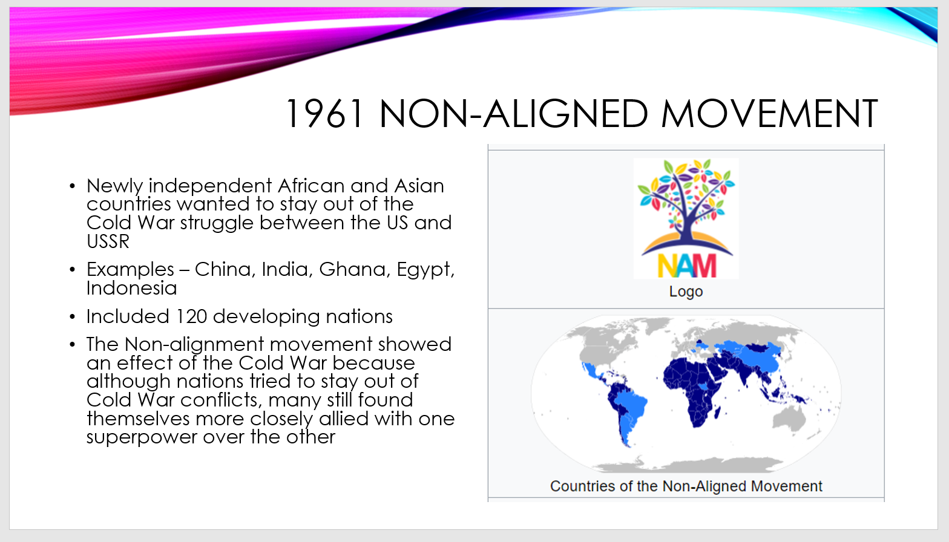**Task: Create a timeline depicting important events of the Cold War. Make a PowerPoint slide for each event. Include a description of the event, date, visual, and connection to the essential questions. See sample slide below.**

Requirements:

* Title Slide – Include title, your name, visual representing the Cold War.
* **12 Content Slides** – select events from the list on the next page. Include at least one event from each category. *Be sure to explain how each event relates to one of the essential questions!*
* Arrange content slides in chronological order by date – earliest to most recent.
* Check your work and make corrections for spelling and grammar.

Early Years:

Yalta and Potsdam Conferences

Truman Doctrine

Marshall Plan

Berlin Airlift

Alliances:

NATO

Warsaw Pact

Nuclear Weapons:

Nuclear Arms Race

Cuban Missile Crisis

Proxy Wars:

Korean War

Vietnam War

Angolan Civil War

Sandinistas-Contras Conflict in Nicaragua

Soviet Invasion of Afghanistan

Space Race:

Sputnik

Apollo 11 Moon Landing

End of Cold War:

Uprisings in Poland and Czechoslovakia (1968)

Glasnost and Perestroika

Fall of Berlin Wall

Fall of Soviet Union